**1 kHz sinusoidal Vin signal, Vp = 91 mV**

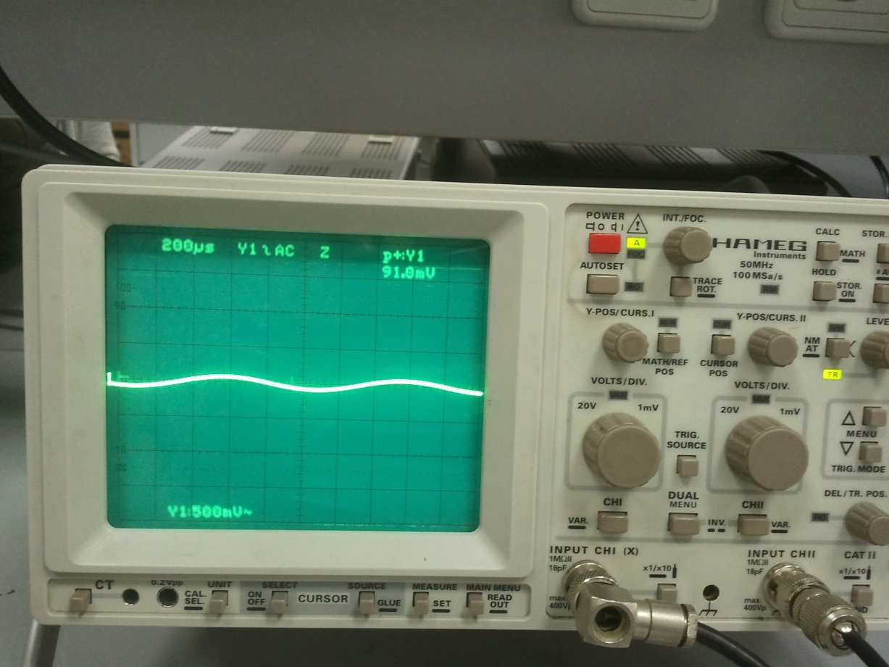

**Vout signal (Amplified signal of Vin), Vp = 3.99 V**

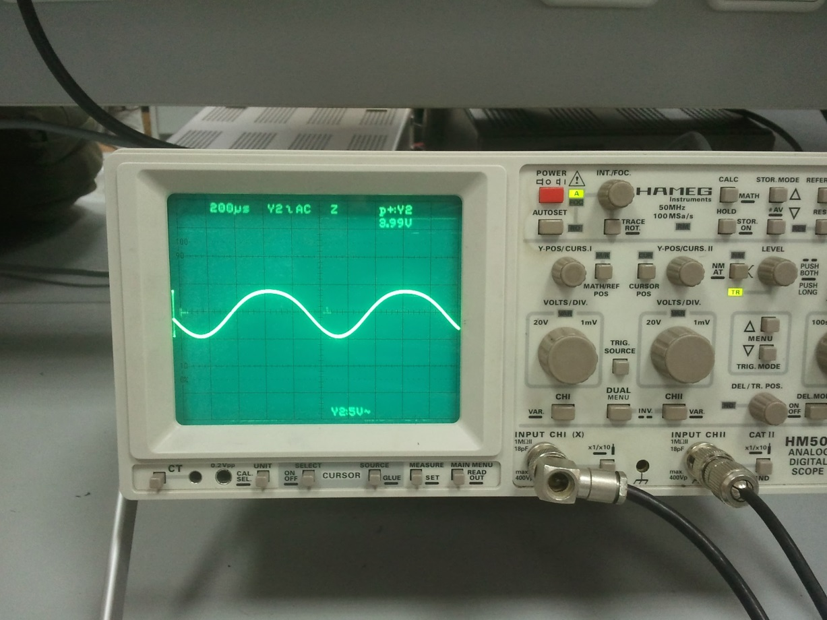

**Vin and Vout signal together**

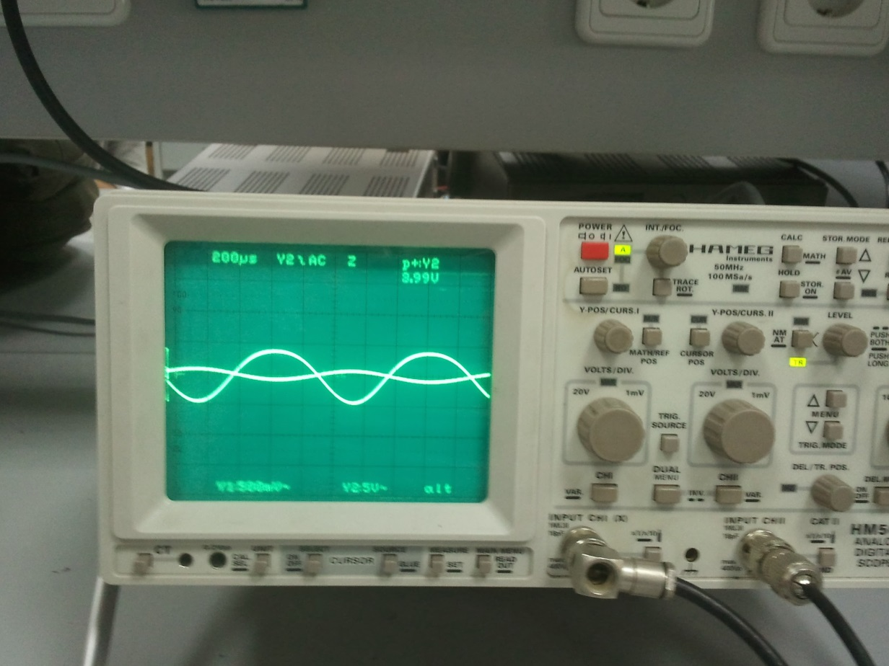

**Vin and Vout signal together when clipping starts**

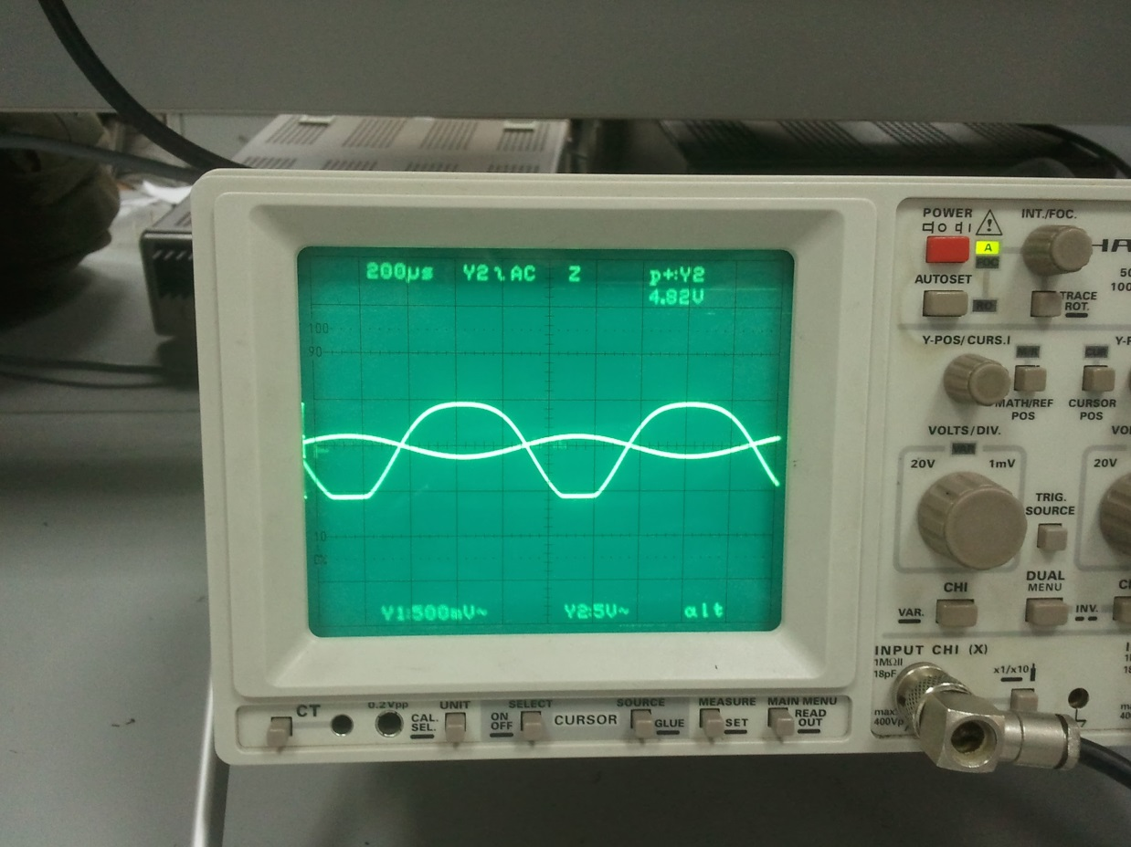

**Circuit in simulation program**

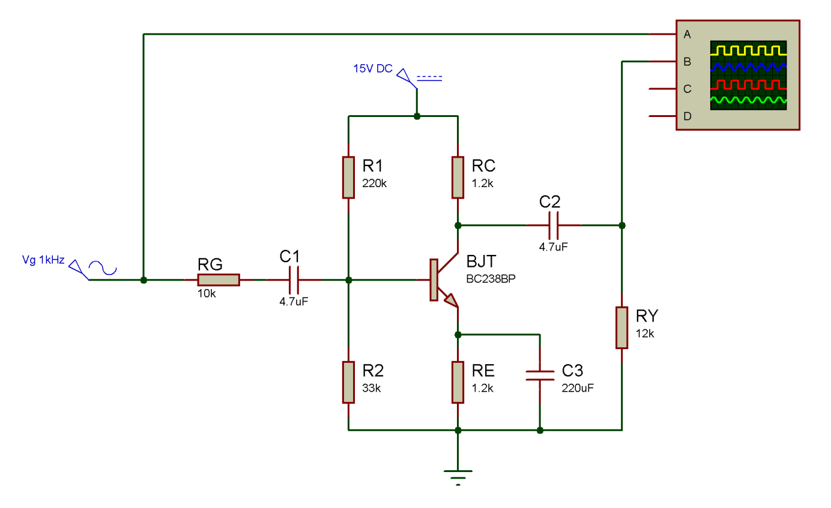

**Simulation Result**

